RNN_LSTM_GRU_keras

test01LSTM_imdb 电影评论二分类
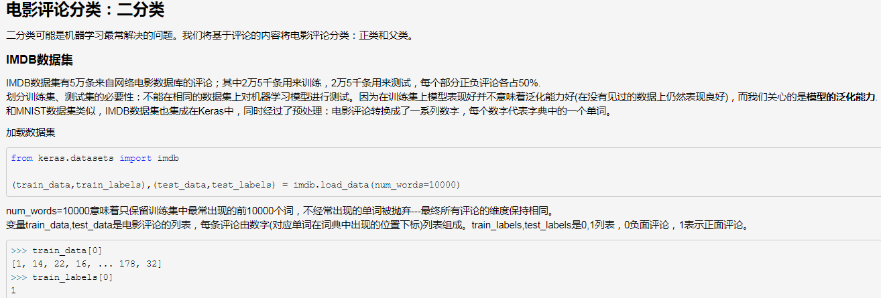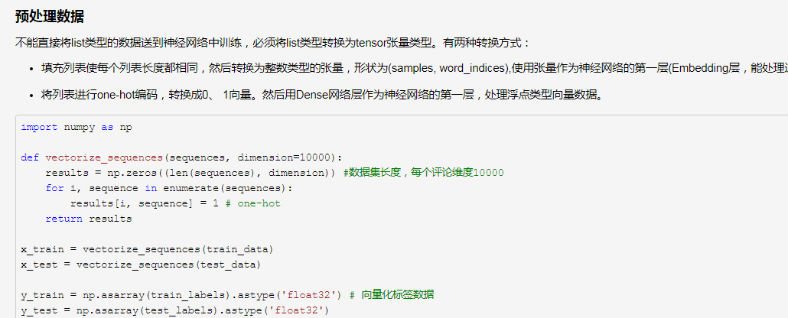
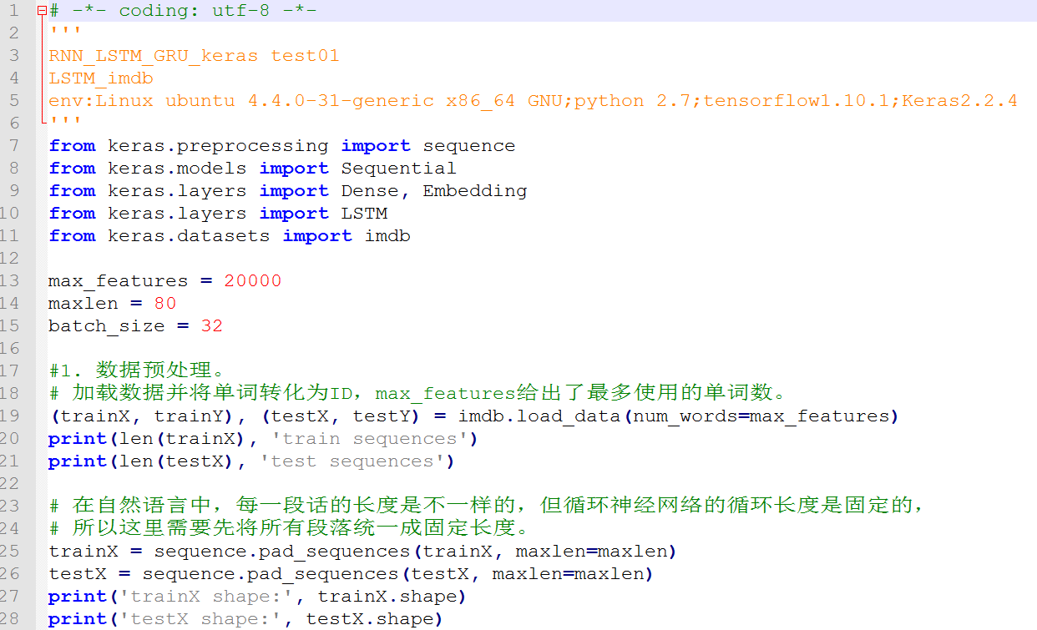

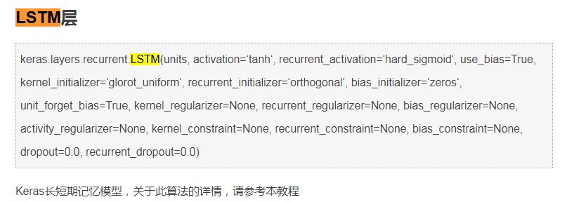
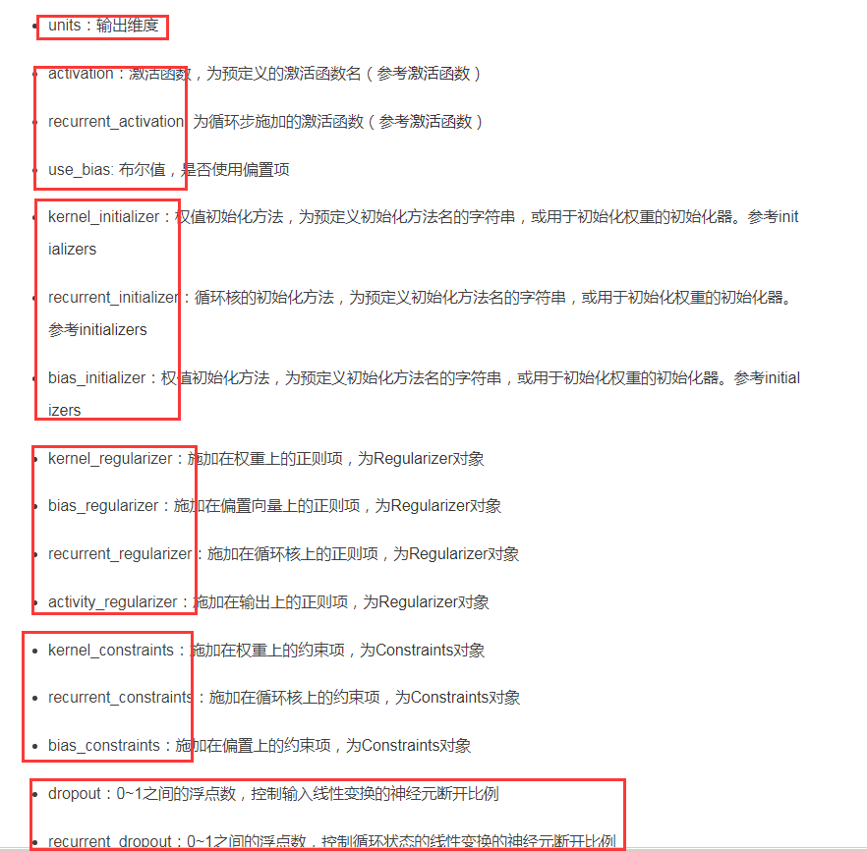
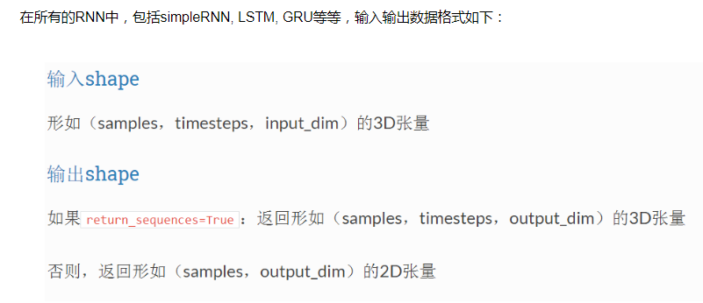
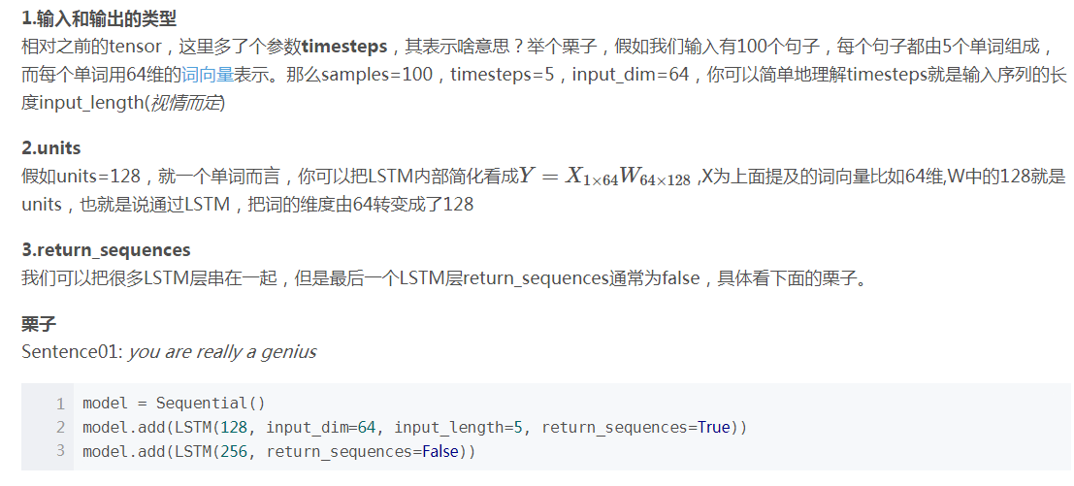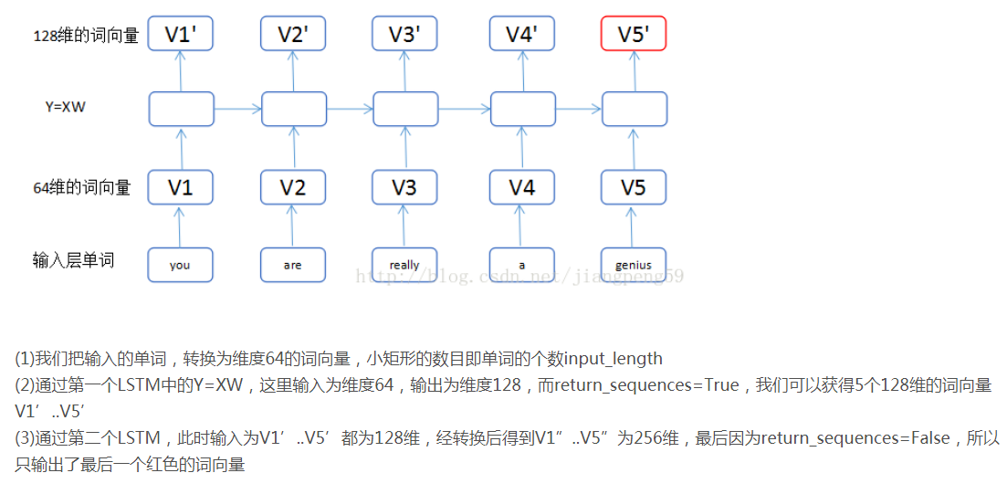
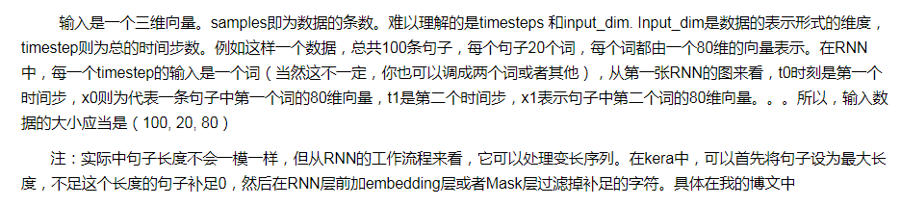
下面为keras2.0 英文官网说明
keras.layers.LSTM(units, activation='tanh', recurrent_activation='hard_sigmoid', use_bias=True, kernel_initializer='glorot_uniform', recurrent_initializer='orthogonal', bias_initializer='zeros', unit_forget_bias=True, kernel_regularizer=None, recurrent_regularizer=None, bias_regularizer=None, activity_regularizer=None, kernel_constraint=None, recurrent_constraint=None, bias_constraint=None, dropout=0.0, recurrent_dropout=0.0, implementation=1, return_sequences=False, return_state=False, go_backwards=False, stateful=False, unroll=False)
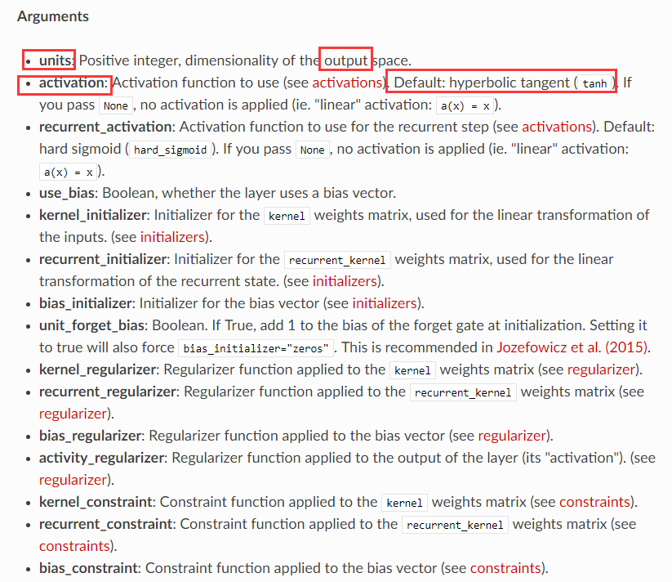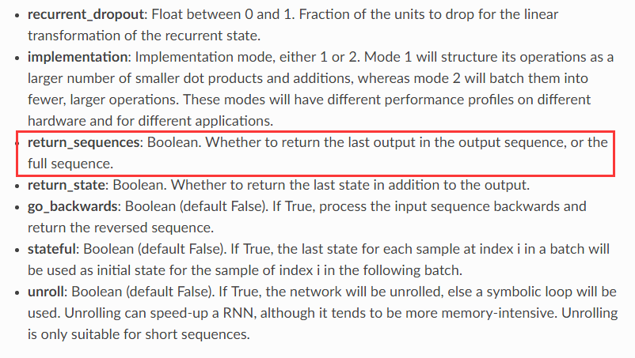
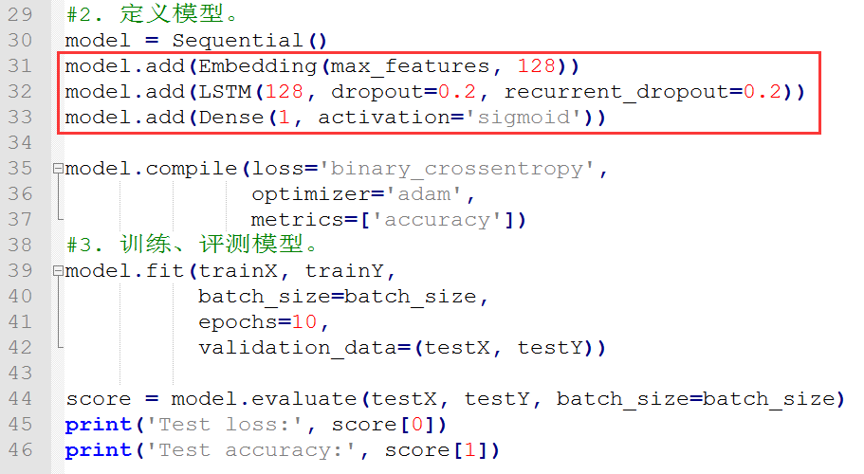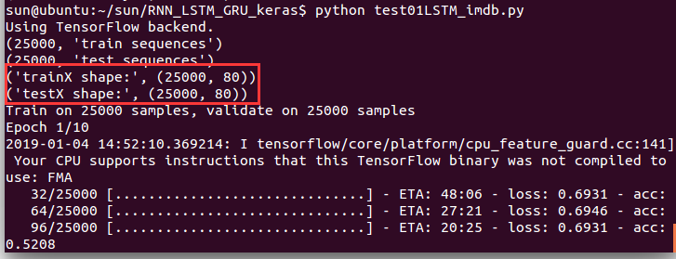
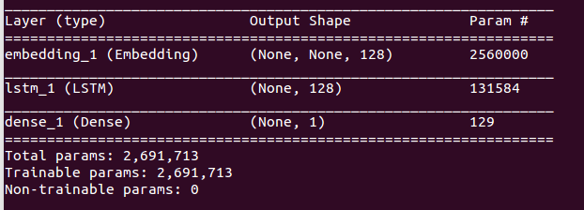
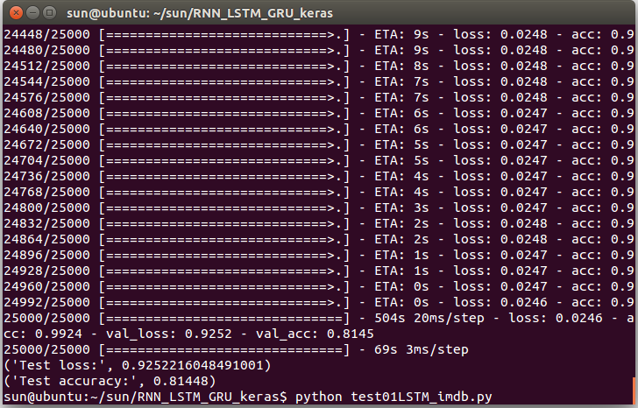

参考：
https://www.cnblogs.com/ysugyl/p/9305857.html
https://www.cnblogs.com/leeshum/p/6133290.html
http://www.mamicode.com/info-detail-2217844.html
https://blog.csdn.net/jiangpeng59/article/details/77646186
https://keras.io/layers/recurrent/#lstm

其他：


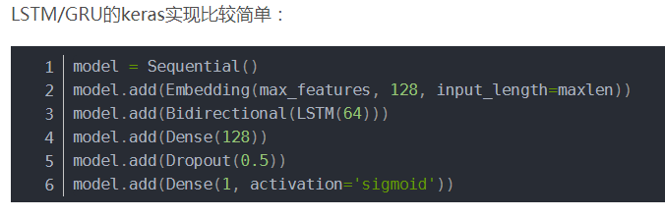
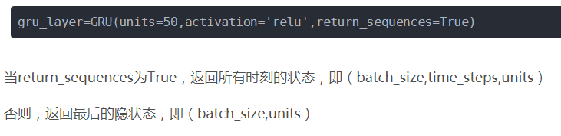

参考：
https://blog.csdn.net/Julialove102123/article/details/80757685

